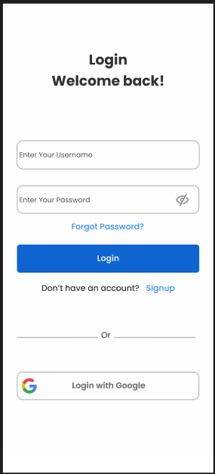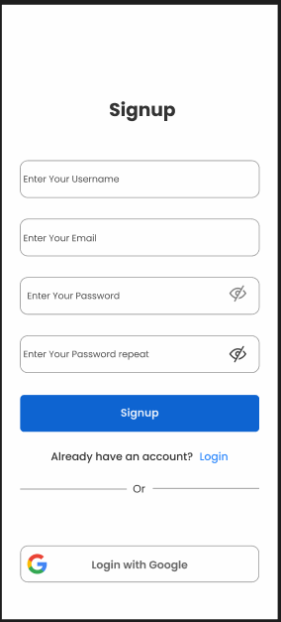

[Login & Signup Form Android By VSL (Community) – Figma](https://www.figma.com/file/5kZaSEm8J2K4pn2tOFsMMa/Login-%26-Signup-Form-Android-By-VSL-(Community)?type=design&node-id=0-1&mode=design&t=5YLa7k5ZY5PWqRJr-0)



